Step 4 : In the src make a “components” folder
(NOTE : the folder structure should be like DOM TREE)
Utility elements,which are frequently resued in the app such as button keep them in the shared folder)
NOTE : component name should compulsory PascalCase
NOTE : for every component have a separate CSS & JSX file(recommended) .

In the jsx file type “rafce” to create a functional component
const Navbar = () => {
return (
<div>Navbar</div>
)
}

In the app.jsx add the component(remember to import the component u add, to import ctrl+spacebar)
import React from 'react'
import Navbar from './components/navbar/Navbar'

const App = () => {
return (
<>
<Navbar /> //ctrl spacebar and import the Component
</>
)
}
NOTE : to import the component ctrl spacebar + enter

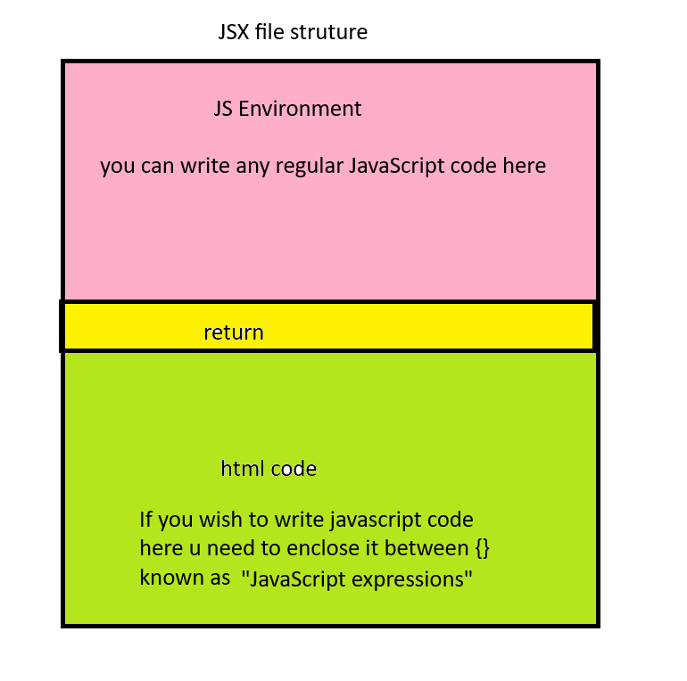
the js code written in jsx file should be written above the return statement
e.g console.log
all the manipulation part in the jsx should be done before the return after the return we can only read the values

Create List Component
const List = () => {

return (
<ul>
<li>A</li>
<li>B</li>
<li>C</li>
<li>D</li>
<li>E</li>
</ul>
)
}

const List = () => {
const cities=["Delhi","Jaipur","Pune","Mumbai"]
return (
<ul>
{
cities.map((city)=>(<li>{city}</li>))
}
</ul>
)
}

Conditional rendering

const Message = () => {
const name = “Alice”
if(name)
{
return <h1>Hello {name} </h1>
}
else
{
return <h1>Hello World</h1>
}

const Message = () => {
const name = “”
if(name)
{
return <h1>Hello {name} </h1>
}
else
{
return <h1>Hello World</h1>
}

